

**SCSJ1O23-O3 PROGRAMING TECHNIQUE II**

SEMESTER 2, 2O19 / 2O2O

**GROUP PROJECT : FIRST DRAFT**

**THEME : MOVEMENT CONTROL ORDER (MCO)**

Lecturer : Madam Lizawati Binti Mi Yusuf

Prepared by :

|  |  |
| --- | --- |
| **Name** | **Matric No** |
| Muhammad Hafizh Herti Arrabbani | A19EC0261 |
| Abu Bakar Bin Ahmad Bashir | A18CS3040 |

**INTRODUCTION TO THE SYSTEM**

The 2020 Movement Control Order, commonly referred to as the MCO is a cordon sanitaire implemented as a preventive measure by the federal government of Malaysia in response to the coronavirus disease (COVID-19) pandemic in the country on 18 March 2020. The order was commonly referred to in local and international media as a "lockdown" or "partial lockdown".

On 16 March 2020, the current Prime Minister of Malaysia, Muhyiddin Yassin made an official speech and officially promulgated the movement control order under the Prevention and Control of Infectious Diseases Act 1988 and the Police Act 1967. The order included the following restrictions : closure of all the public and private higher educational institutions (universities and colleges) and skills training institutes nationwide including both of the Johor Bahru and Kuala Lumpur campuses of the University of Technology Malaysia.

In order to counteract the spread of the virus among the campus residents, the Department of Deputy Vice Chancellor of the University of Technology Malaysia has allowed the fellow students for going back to their respective hometown and ordered the fellow staffs and lecturers to work from home in accordance to the announcement from the Ministry of Higher Education to conduct the teaching and learning process online or through e-learning portals until the December 2020.

Hence, we decided to come out with an application (system) in particular for the School of Computing that could be able to manage the movement of both the students and staffs/ lecturers from this school to keep a record of their whereabouts during this Moment Control Order period. The development and use of this system would be able to assist the academic office of the school to ensure the students and lecturers are in the state of safe and sound during this pandemic.

**OBJECTIVES OF THE SYSTEM**

The foundation of development of this system are intended to :

* tracking the movement of both students and staffs/ lecturers of the School of Computing
* manage the last movement and keep records of their whereabouts such as their personal details and their current residential address information.
* ensure the safety of the fellow students and staffs/ lecturers of the school during the movement control order.
* record and identify the number of students prefer to engage in online learning from their respective home and from the university campus.
* could able the academic office to keep and save the students recorded information for the emergency contact purposes.

**SCOPES OF THE SYSTEM**

**SYSTEM SCOPE :**

* the system should work properly even at the lowest bandwidth.
* able to receive the input from the user both alphabet and numeric.
* should be trustworthy in record every information entered.
* enable the option for the user selection input process.
* protect user privacy with requiring unique identification number
* able to work based on the initiated system flow.
* should be give an output either in display view or in printed form.
* give a smooth experience for the user interaction between system.

**USER SCOPE :**

* should be able to understand the system requirements
* able to input the information required and options given
* enter the valid and legit information based on the question
* able to navigate through the system flow from start to end.
* should be assisted on how to choose from the selection give.
* could be able to view the output in display and print out in physical format.
* user able to do modification of the options or answer given before submit.
* should able to save and submit after complete the form inside the system.

**PURPOSE/ SIGNIFICANCE OF THE SYSTEM**

Due to the imposed movement control order and implemented online teaching and learning process through e-learning, the proposed system should be able to meet the purpose and significance of what the School of Computing have to do in order to record the current location information of their graduates. This initiative should be part of the school's responsibility for keep track of their graduate's movement until the end of December and to respond to any emergencies regarding to their graduate’s safety and welfare. Apart for the graduates alone, the proposed system has integrated the same initiative for the staff and lecturers to monitor their status during the work from home period.

**FLOWCHART OF THE SYSTEM**

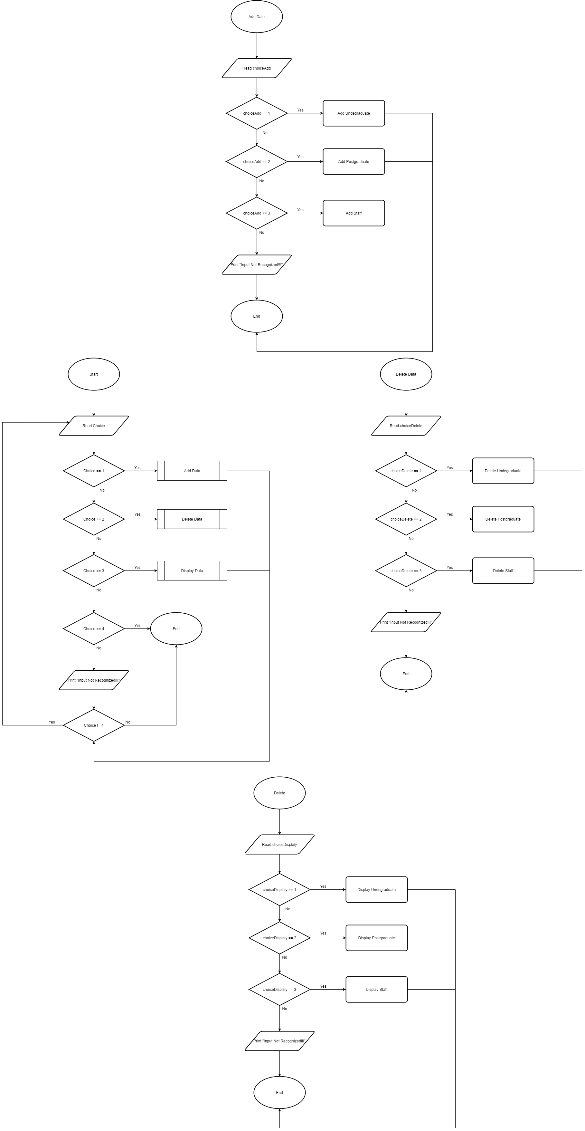

**UML CLASS DIAGRAM**

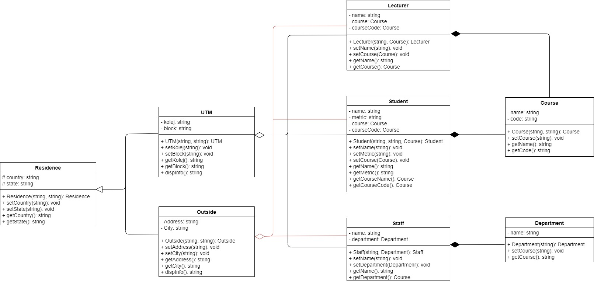

**TASK DISTRIBUTION**

**BOTH MEMBERS :**

* initiate the idea of the project and the selection of the topic.
* research about the topic background and project purpose.
* creating Google Form and distribute for surveying.
* data collection for the identification of potential options.
* search and look out for the external source code references.
* preparing the paper works and final project report documentation.
* get prepared for the project presentation on respective parts.

**MUHAMMAD HAFIZH :**

* Figure out the system flowchart/ work flow.
* Creating the UML diagram and use case diagram.
* Creating the base code for the program.
* In charge of the main part and the function surrounding it.
* Distribute tasks and project management between members.

**ABU BAKAR :**

* initiate the project background and objectives.
* elaborate the scope of the proposed system.
* arrange the scheduled meeting between the members.
* In charge of the header part of the source code.

**REFERRED SOURCE CODE**

* **Assignment 1; Online Learning Week 4; xyzstore question**